**Cognizant_Digital Nurture 4.0_Deep Skilling**

**Platforms & GenAI**

**Module 11 – Version control – GIT**

**1. Version Control Using Git and GitLab: Initial Setup and First Push**

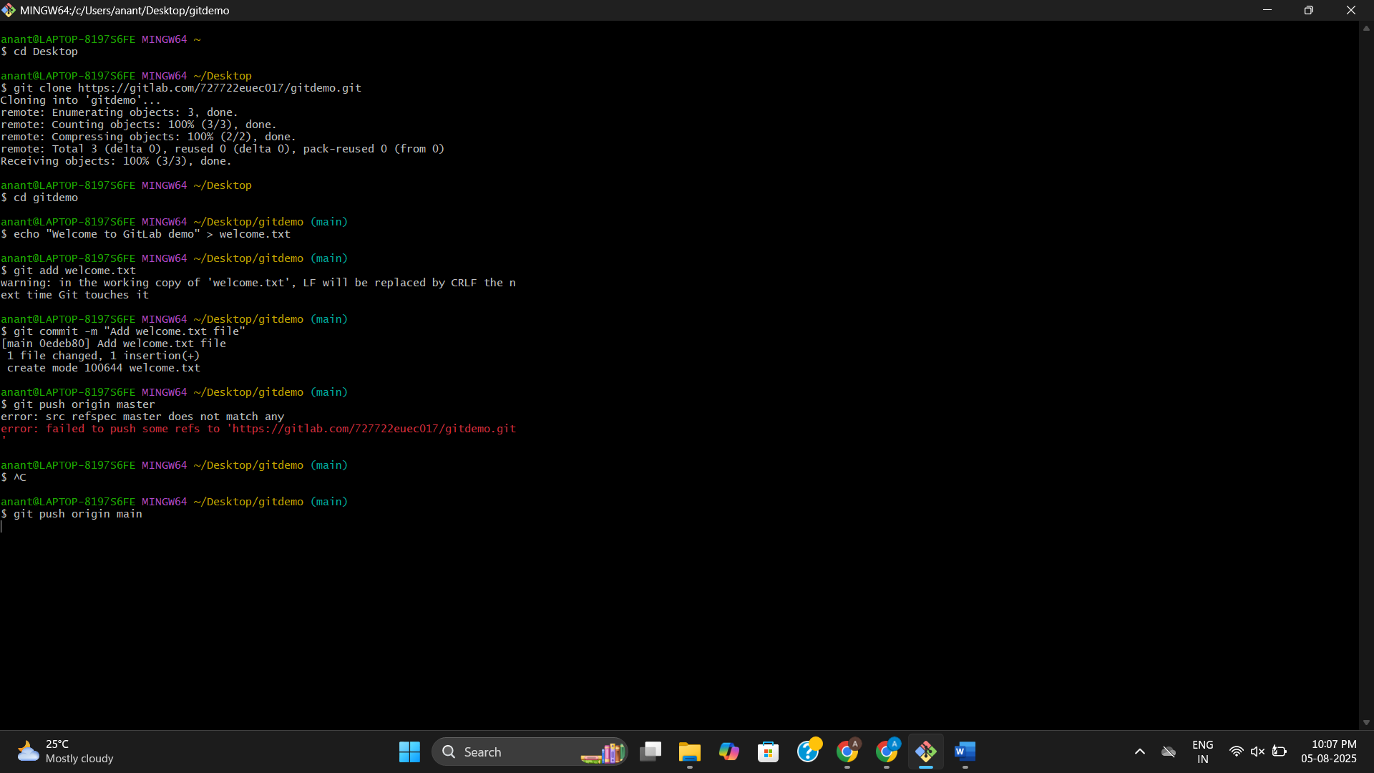

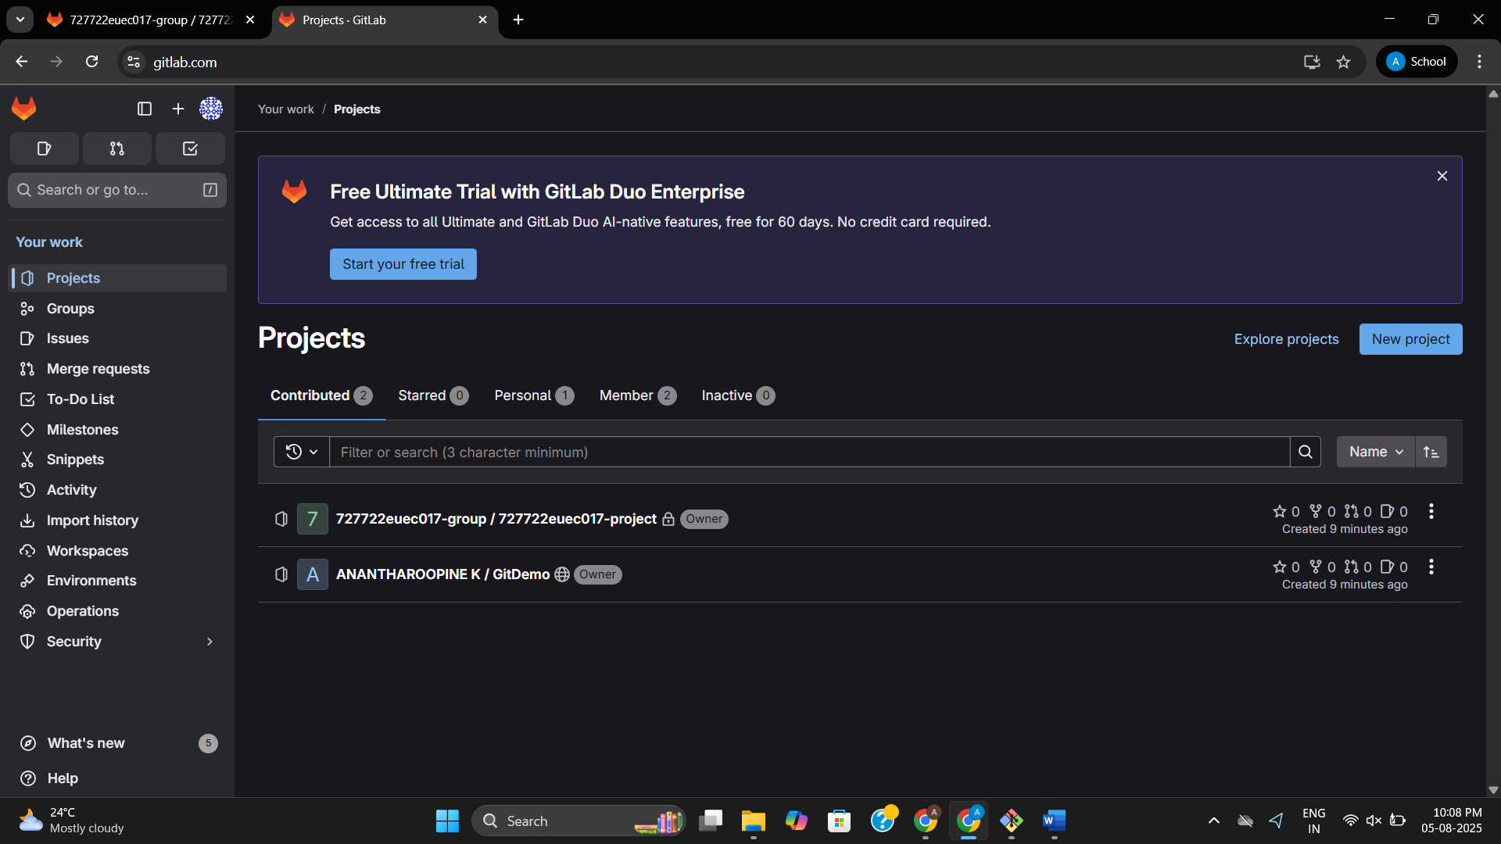

**2.Managing Untracked Files Using .gitignore in Git and GitLab**

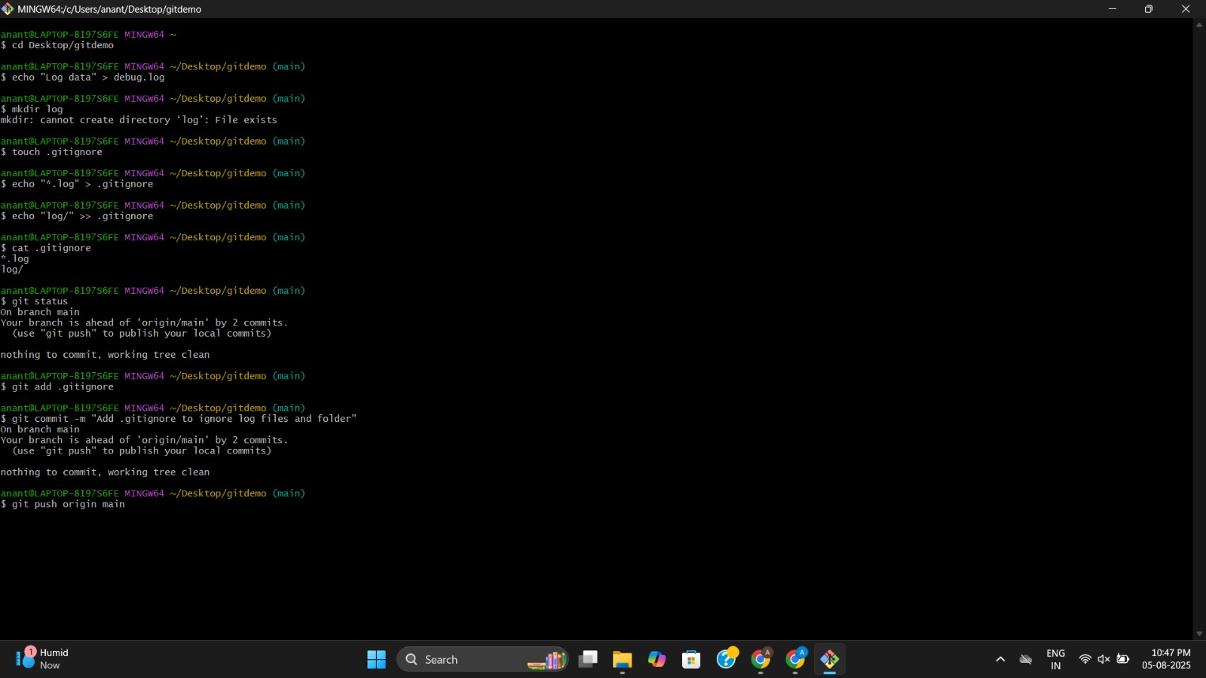

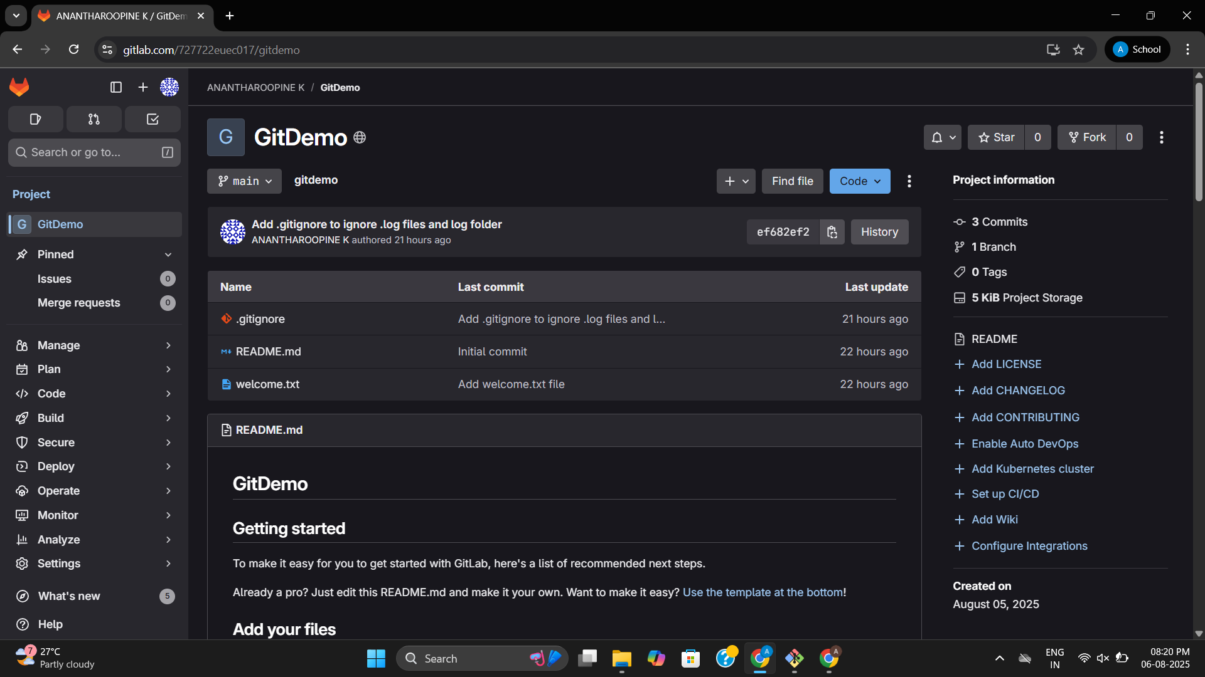

**3. Branching and Merging in GitLab**

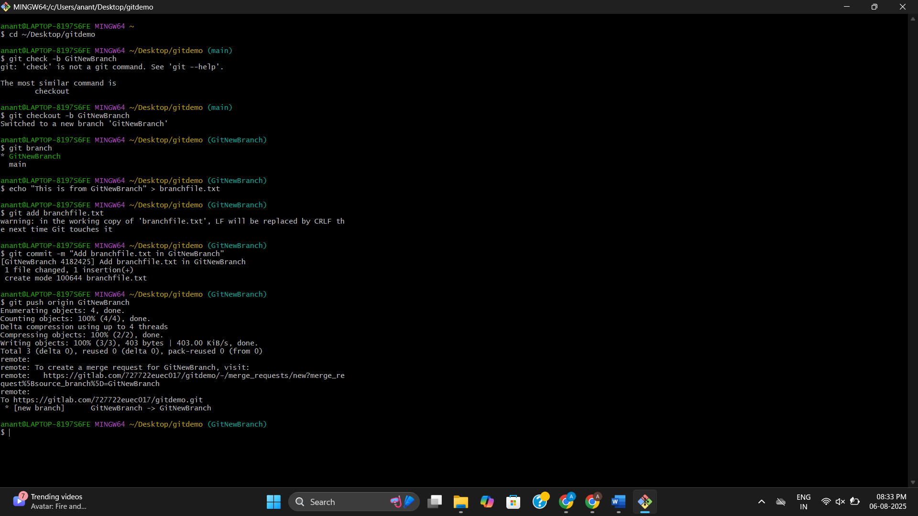

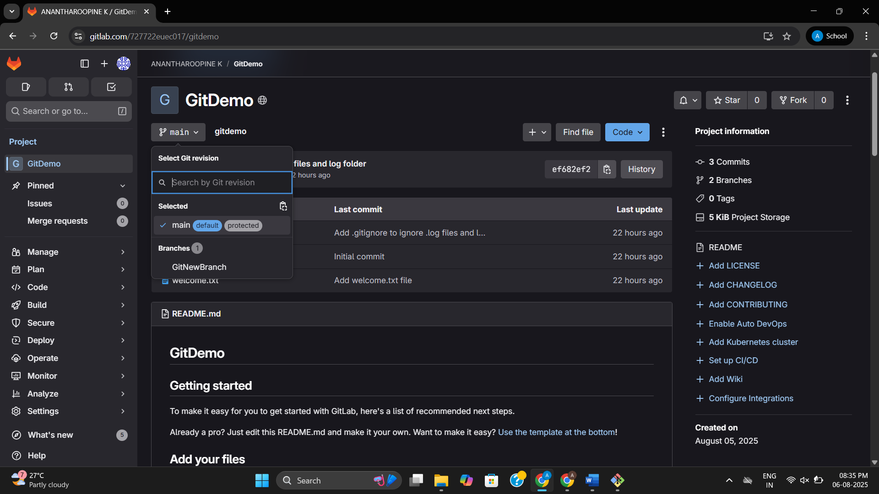

**4: Conflict Resolution during Merge**

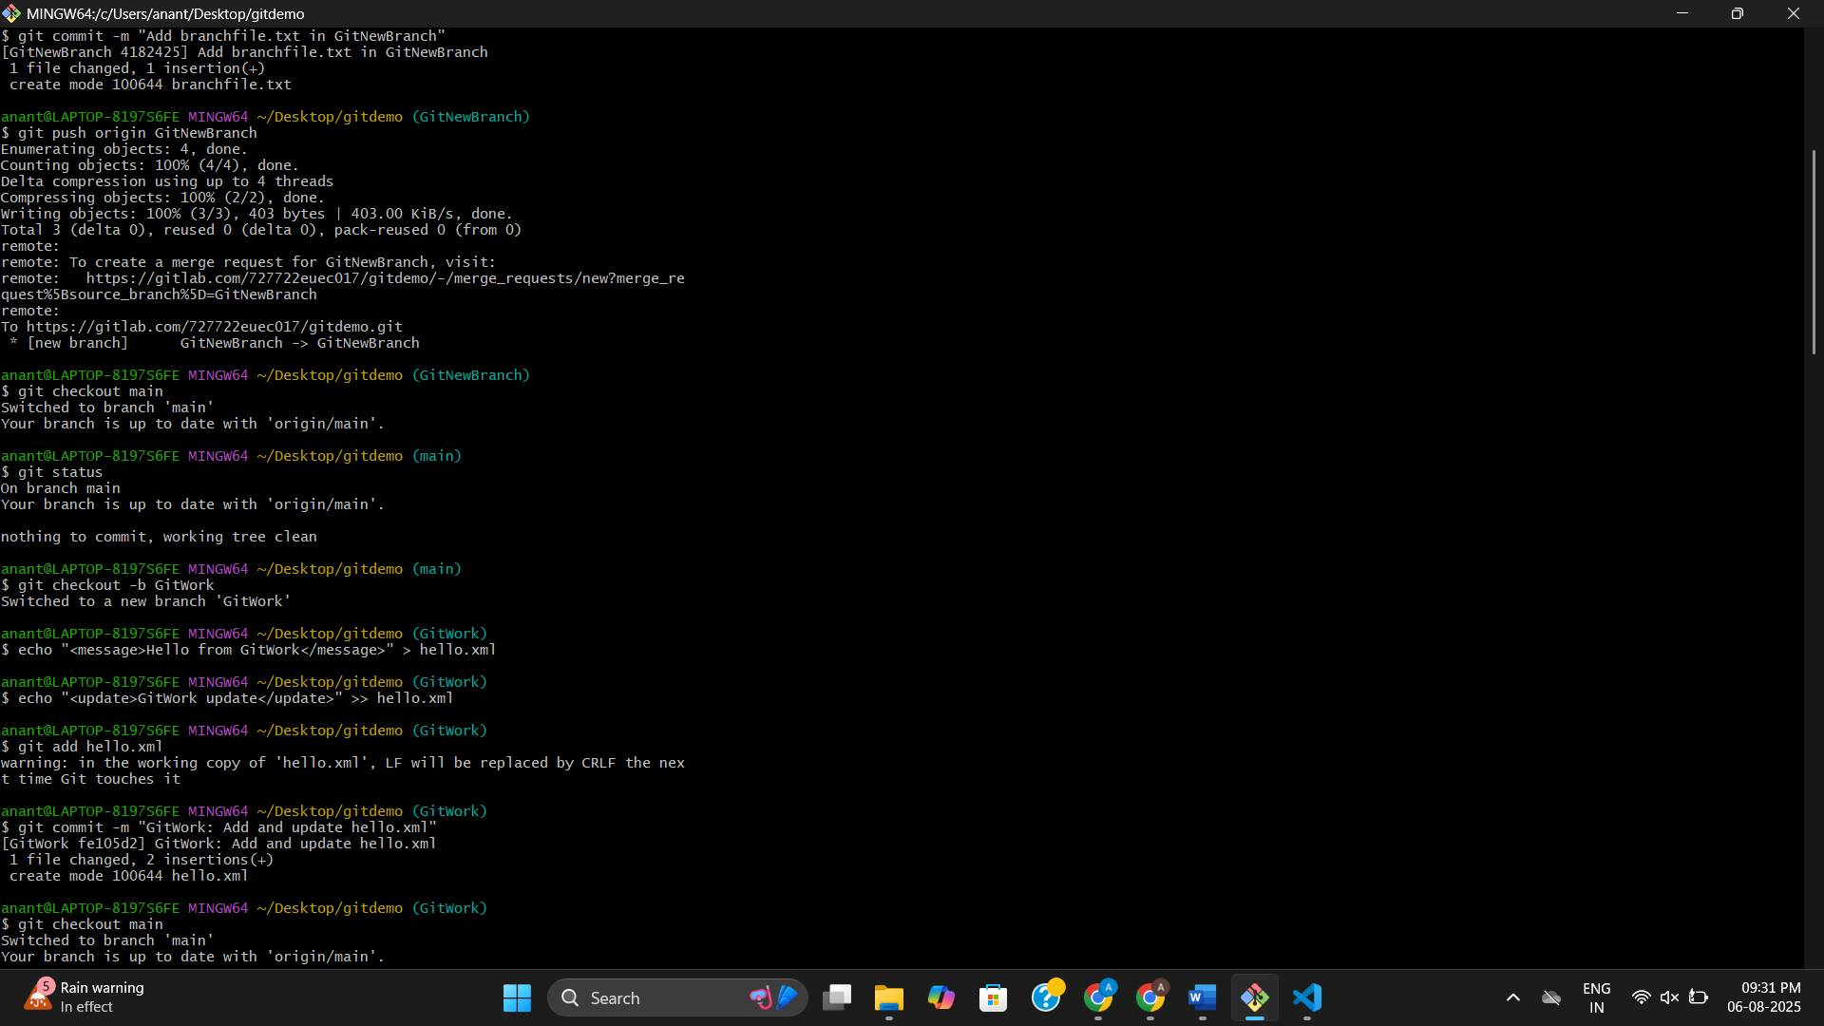

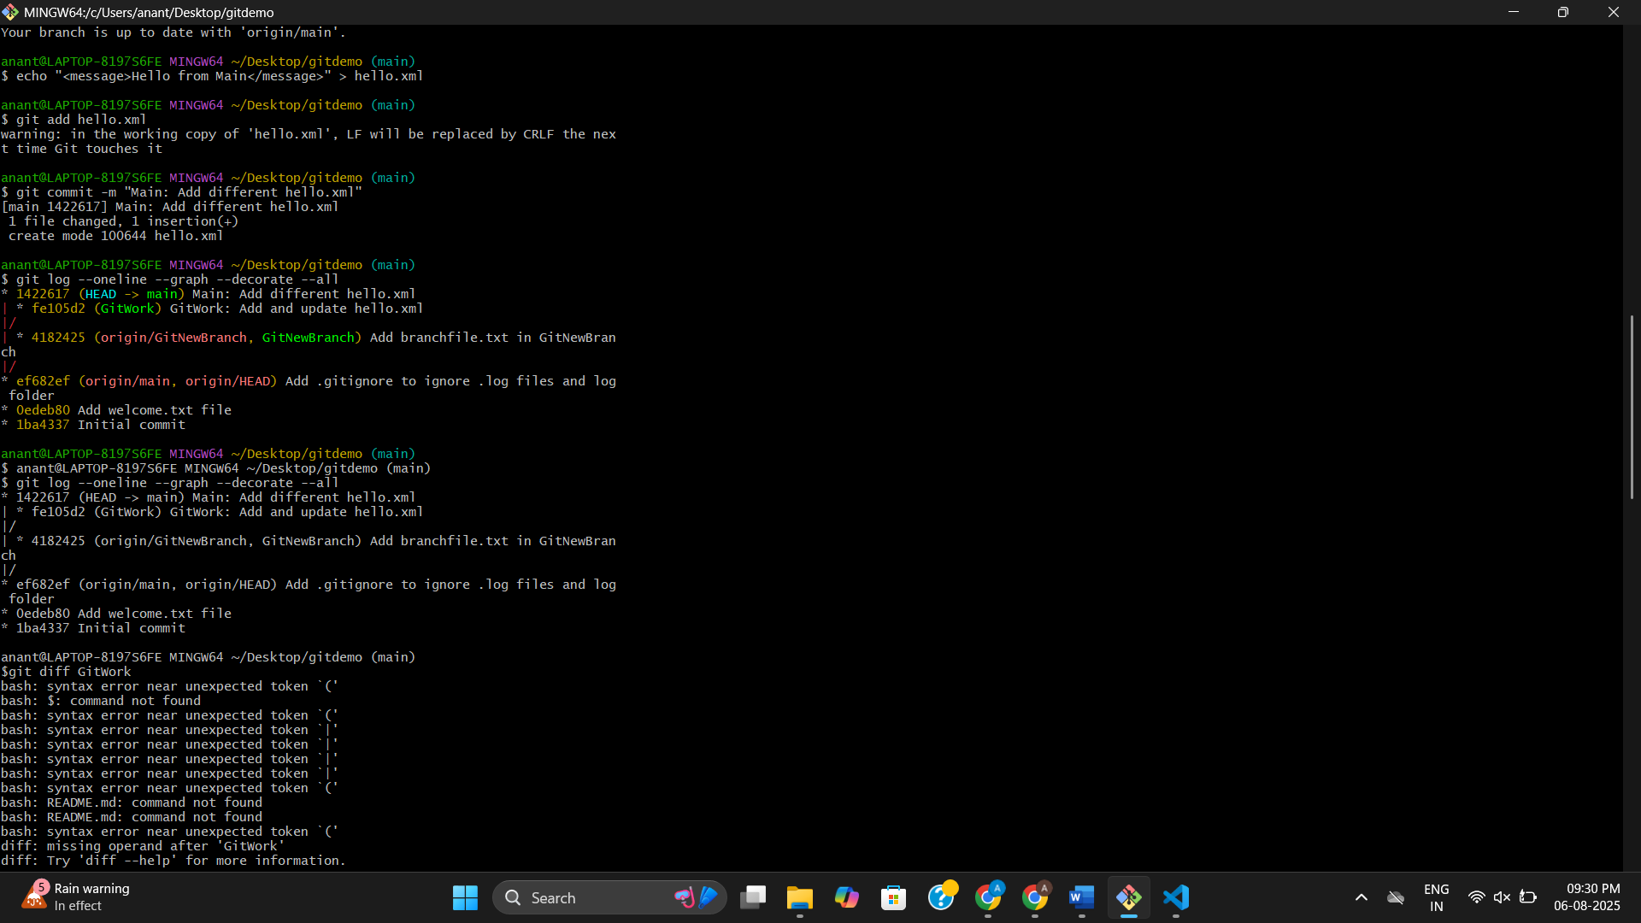

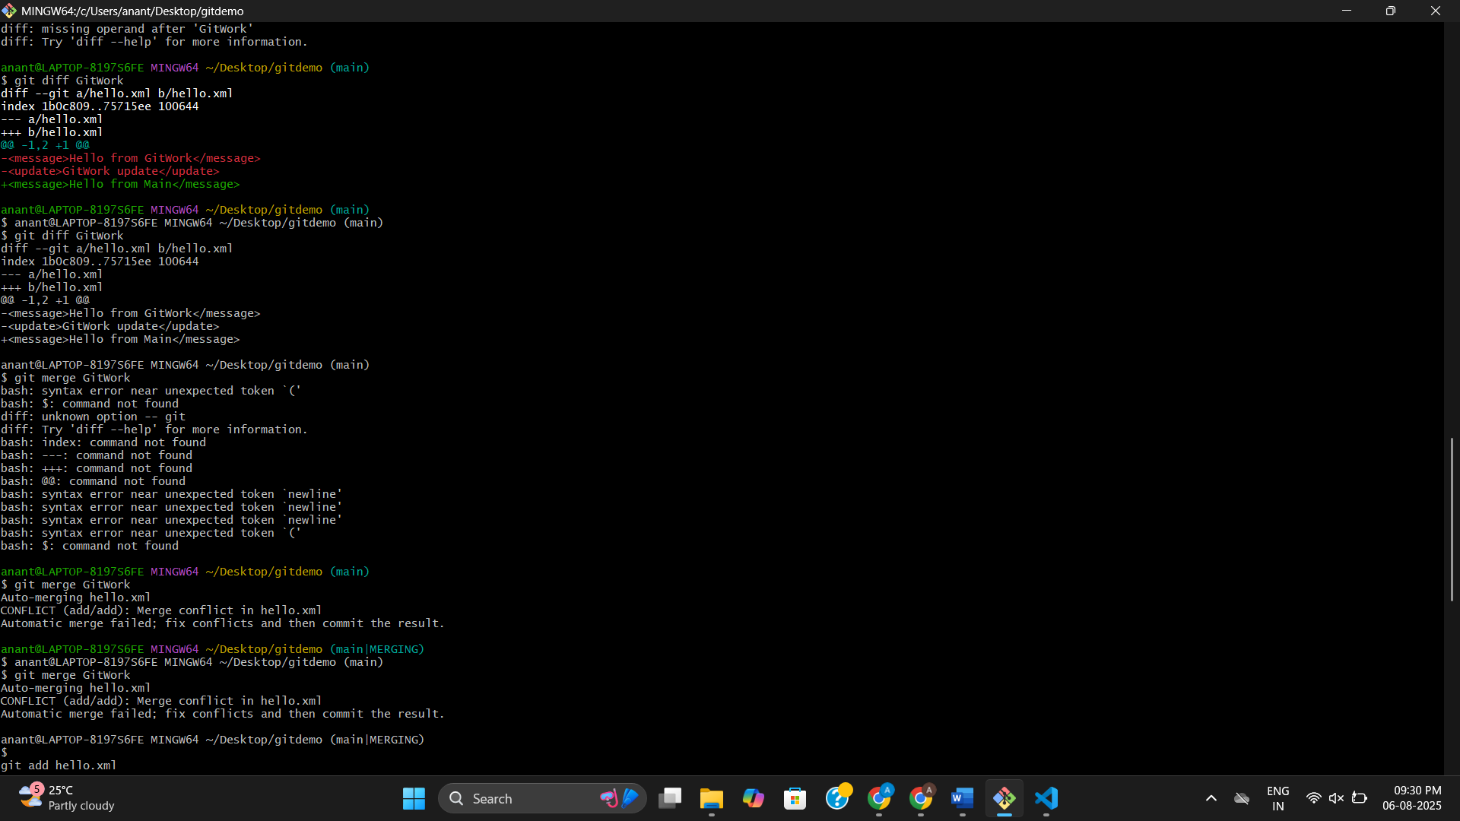

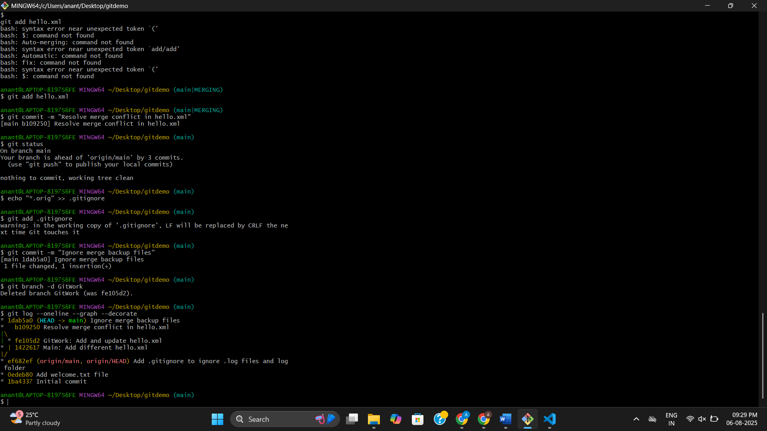

**Exercise 5: Clean Up and Push to Remote Git**

